# Stacking interactions in “layered” energetic crystals: insights into electronic properties of supramolecular architecture defining macroscopic mechanical features

## I.V. Omelchenko1

### 1Institute of Functional Materials Chemistry, SSI “Institute for Single Crystals” NAS of Ukraine, 60 Nauky ave., Kharkiv 61001, Ukraine

### irina@xray.isc.kharkov.com

Quantum chemical analysis of the crystal structures of three nitrogen-based energetic materials – symm-triaminotrinitrobenzene (TATB), 4-amino-1,3-dinitrobenzene (MADB4), and 1,1-diamino-2,2-dinitroethylene (FOX7) reveals that, despite differing molecular structures, they possess interesting similarities in their packing patterns. Although the synthon theory typically favours intermolecular hydrogen bonds as main driving force of the crystal architecture, it turned out that it is not hydrogen bonding but stacking interactions secure packing type in nitroaromatic species and have significant effect on FOX7 polymorphs packing. In all crystals, most of observed macroscopic mechanical properties also defined by stacking.

The TATB is known for its “layered graphite-like” arrangement of molecules in crystals which are believed to be supported by intramolecular hydrogen bonds. Triclinic polymorph modification of FOX7 possesses very similar packing pattern. The MADB4 molecule, having molecular structure close to TATB, reveal wave-type layered arrangement, which resembles crystal architecture in monoclinic and orthorhombic FOX7 polymorphs. However, close study of pairwise intermolecular interactions by energy vector diagram (EVD) [1] method revealed that the main force that affects supramolecular organization in nitroaromatics is stacking, and in FOX7, it is second strongest interaction. Being stronger in nitroaromatic species and weaker in non-aromatic FOX7, stacking still define the shape of basic structural motifs.

Overall difference between planar and wave-type structures only depends on molecular shape but not on compound class: nitrogen group rotation with respect to molecule plane results in wave-type crystal packing while planar molecules favour planar arrangement. In both cases, it’s driven rather by the force of multiple stacking interactions.

Mechanical response of crystal structures studied on microscopic level reveal the leading role of stacking in pressure absorption. This effect is most pronounced in coplanar arrangements (e.g., TATB, triclinic FOX7), where stacking can buffer mechanical stress effectively. It explains exceptional impact stability of TATB, however in case of FOX7, a torsional strain of nitro groups diminishes the efficacy of this mechanism. Stacking dimers are capable of energy dissipation through modulation of interplanar distances across a broad range without altering the interaction type. Wave-like packing patterns in MADB4 and m/o-FOX7 restricts this flexibility but still supports smooth pressure response.

Notably, stacking also facilitates sliding deformations, which may act as an energy-buffering mechanism on the macroscopic scale. The non-local electronic properties of stacking reduce sliding barriers, enhancing sliding without sharp energy increase. This effect is the most prominent in TATB where the estimated sliding barrier can be as low as 1 kcal/mol.

Thus, focusing on molecular fragments that make stacking favourable in crystals might be the viable strategy in crystal engineering for tuning mechanical stability of nitrogen-based energetic materials, not only of aromatic but also non-aromatic π-conjugated species.

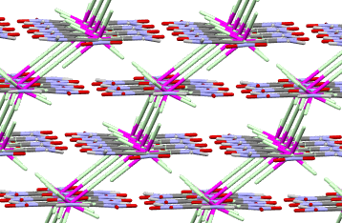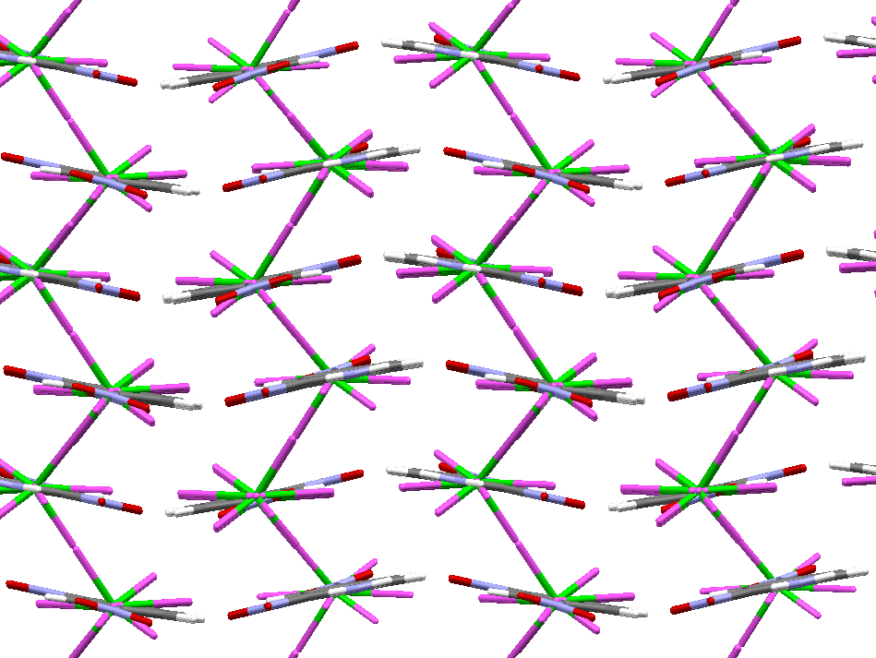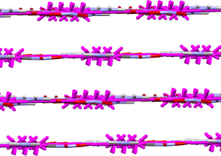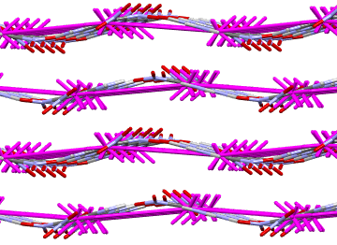

###### **Figure 1**. Stacking interactions shaping supramolecular architecture of TATB, MADB4, t-FOX7 and m-FOX7 crystals (left to right).

#### [1] Shishkin, O. V., Zubatyuk, R. I., Shishkina, S. V., Dyakonenko, V. V., Medviediev, V. V. (2014). *Phys. Chem. Chem. Phys.* **16**, 6773.

The author(s) are grateful to the FAIRE programme provided by the Cambridge Crystallographic Data Centre (CCDC) for the opportunity to use the Cambridge Structural Database (CSD) and associated software.