# Synergy between STEM imaging and 3D electron diffraction in crystallography

## S. Kodjikian1, A. Raynal1, C. Lepoittevin1, F. Denis Romero1

### 1Univ. Grenoble Alpes, CNRS, Grenoble INP, Institut Néel, 38000 Grenoble, France

### stephanie.kodjikian@neel.cnrs.fr

In solid-state chemistry, it's not unusual for the search for new physical properties to lead to the discovery of an unknown compound, especially when syntheses take place under extreme temperature and pressure conditions. In such cases, transmission electron microscopy (TEM) is a highly appropriate characterization tool, as it enables chemical composition information to be combined with structural information on the same particle, whether using the new 3D electron diffraction (3D ED) methods or by interpreting STEM images in chemical contrast.

For example, a new Pb Fe Ge oxide was recently discovered in our laboratory. Single-crystal X-ray diffraction (SCXRD) data led to a first satisfactory structural model, but further refinement failed to determine with certainty the distribution of Fe and Ge atoms on the different crystallographic sites.

An in-depth structural study was then undertaken on the laboratory's STEM JEOL NEOARM microscope.

Although the results of the compositional analysis (EDX) were in good agreement with the structural model obtained by SCXRD, Z-contrast imaging at atomic resolution revealed the presence of stacking faults, a disorder also highlighted by the presence of scattering lines on the electron diffraction images (fig.1 a and b).

We present the strategies that we have tested for applying 3D ED structural resolution methods in the presence of such defects, and the results obtained.

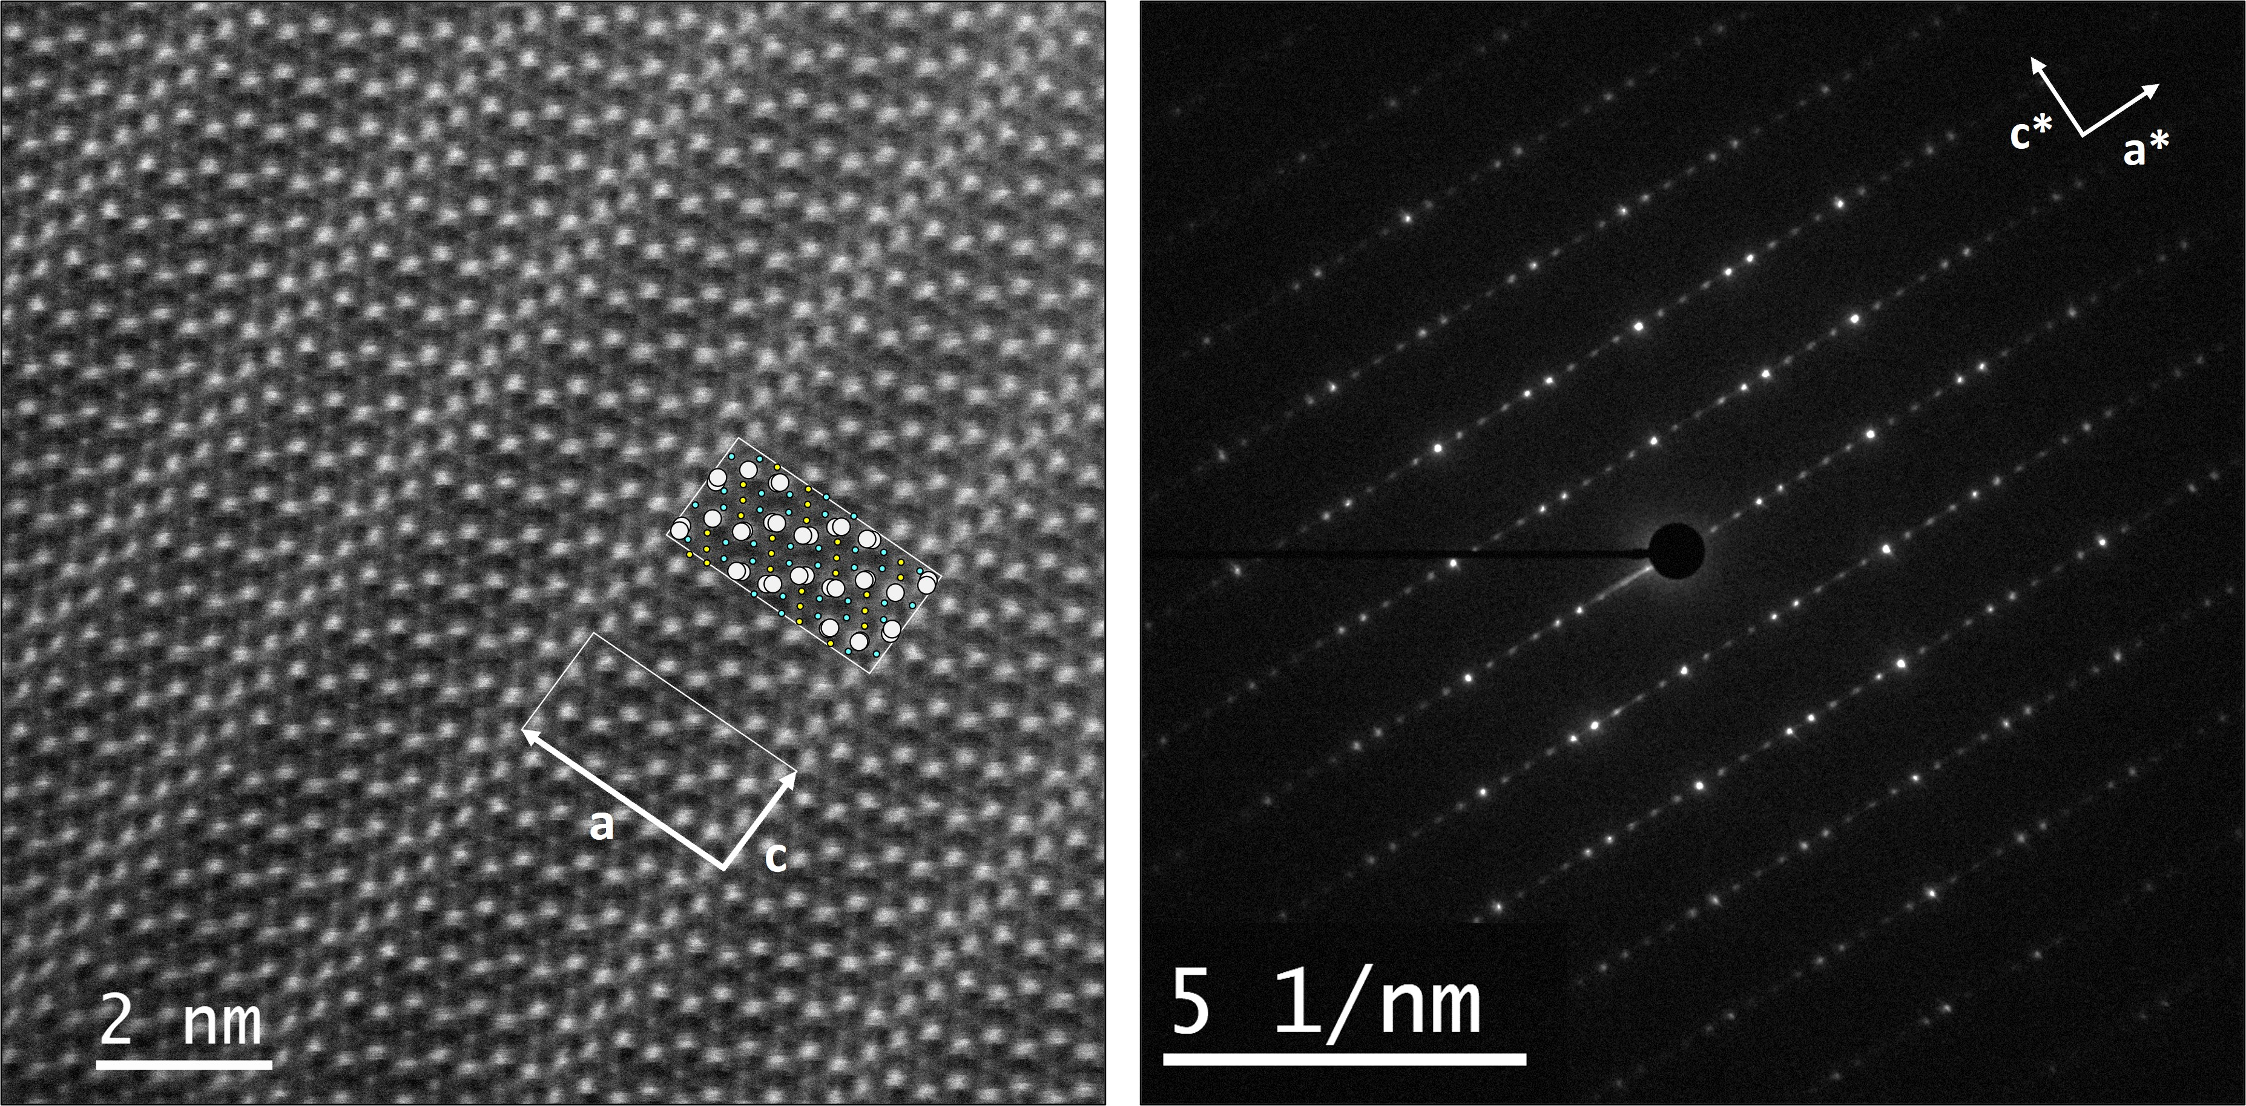

###### **Figure 1**. a) Stacking faults highlighted by STEM-HAADF imaging and b) associated electron diffraction pattern.

Acknowledgements. The TEM facility JEOL NEOARM at CNRS Institut Néel was co-financed by the European Union under the European Regional Development Fund (ERDF, contract no. RA0023813).