# High-pressure study of the charge density wave evolution in SmNiC2

## A. Eich1, A.-A. Haghighirad1, A. von Ungern-Sternberg Schwark1, M. von Westarp1, G. Garbarino2, M. Le Tacon1, M. Merz1,3, S.-M. Souliou1

### 1Institute for Quantum Materials and Technologies, Karlsruhe Institute of Technology, 76344 Eggenstein-Leopoldshafen, Germany, 2European Synchrotron Radiation Facility, CS 40220, 38043 Grenoble Cedex 9, France,

### 3Karlsruhe Nano Micro Facility (KNMFi), Karlsruhe Institute of Technology, 76131 Karlsruhe, Germany

### andreas.eich@kit.edu

In the family of rare-earth nickel dicarbides, *R*NiC2 (*R* = rare earth), a large variety of different charge density wave (CDW) and magnetic states is observed depending on the incorporated element *R*. The observed changes in the characteristic charge ordering and its interplay with magnetism upon substitution are partially attributed to the chemical pressure exerted throughout the series of rare-earth elements. Hence, it is of particular interest to investigate the effect of applied hydrostatic pressure on the individual *R*NiC2 compounds to elucidate the role of pressure within this system.

SmNiC2 exhibits an incommensurate CDW with propagation vector *q*CDW-1 = (½, ½+*η*, 0), *η* ≈ 0.02, below *T* = 148 K, evident from X‑ray powder diffraction and resistivity measurements [1]. At *T*C = 17.7 K, SmNiC2 undergoes a first-order phase transition to a ferromagnetic state, coupled to an abrupt suppression of the CDW [1]. This strong interplay of the charge order and magnetic order indicates a weakening of the Fermi surface nesting conditions responsible for the CDW formation in favour of the ferromagnetic ordering [2,3]. The existence of a second, commensurate CDW with *q*CDW-2 = (½, ½, ½) is implied by diffuse X-ray scattering between room temperature and *T*C [1].

To investigate the evolution of the charge ordering in SmNiC2, we have performed single-crystal X-ray diffraction experiments at simultaneously low temperature and high pressure at the European Synchrotron Radiation Facility (ESRF). Our findings evidence the suppression of the well-known incommensurate CDW with *q*CDW-1 at increased pressures as well as confirm the full formation of the commensurate *q*CDW-2 CDW as shown in Figure 1. In addition, we observe a new incommensurate CDW with propagation vector *q*CDW-3 = (½, ½, *ξ*), *ξ* ≈ 0.06, coexisting with the other CDW in a region at elevated pressures and low temperature.

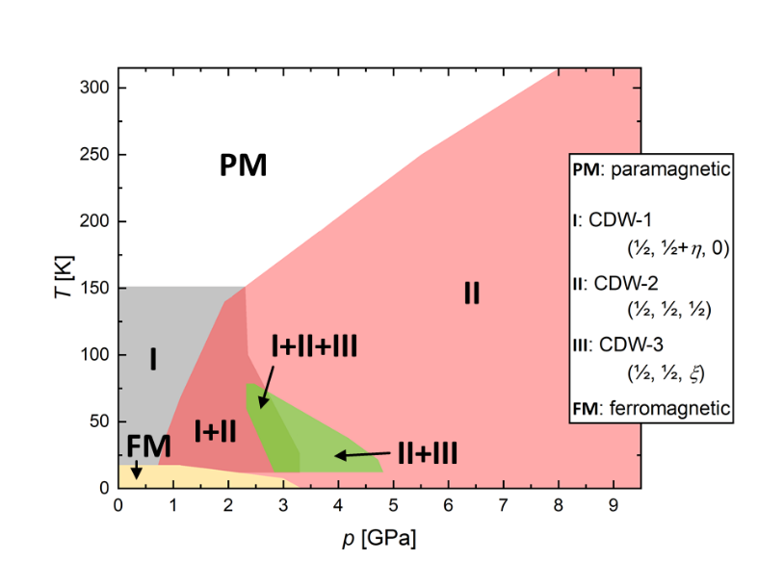

###### **Figure 1**. Pressure–temperature phase diagram of the different charge density waves in SmNiC2. The colours indicate the approximate stability fields for the different CDW.

#### [1] Shimomura, S., Hayashi, C., Asaka, G., Wakabayashi, N., Mizumaki, M. & Onodera, H. (2009). *Phys. Rev. Lett.* **102**, 076404.

#### [2] Laverock, J., Haynes, T. D., Utfeld, C. & Dugdale, S. B. (2009). *Phys. Rev. B* **80**, 125111.

#### [3] Kim, J. N., Lee, C. & Shim, J.-H. (2013). *New J. Phys.* **15**, 123018.

This work was funded by the Deutsche Forschungsgemeinschaft (DFG, German Research Foundation) – 441231589; 422213477 (TRR 288 project B03).