# Benchmarking the 3D-ΔPDF using in-house X-ray sources

## Karl O. R. Juul1, Kristoffer A. H. Støckler1, Bo B. Iversen1

### 1Center for Integrated Materials Research. Department of Chemistry and iNANO, Aarhus University

### Contact: bo@chem.au.dk

The analysis of diffuse scattering from single crystals using the three-dimensional difference pair-distribution function (3D-ΔPDF) has emerged within the last decade [1] and proved useful in understanding the structure of complex thermoelectric materials such as Cu1.95Se [2], metal-organic frameworks like DUT-8 [3], and battery materials [4].

Due to the weak nature of the diffuse scattering, measurements have previously been conducted at synchrotron facilities where extremely high beam flux and short wavelength make them ideal for measurements aimed at 3D-ΔPDF analysis. Recently, Schmidt *et al.* [5] showed that it was possible to perform the same analysis based on data from an in-house Rigaku Syngergy-S diffractometer.

This work focuses at benchmarking the 3D-ΔPDF using a Rigaku Synergy-S diffractometer with characteristic Mo-radiation aimed at a comparison of the in-house source against its synchrotron counterpart using three selected systems. Each system was chosen to highlight different aspects of the 3D-ΔPDF. The first system, Cu1.95Se contains strong diffuse scattering separated from the Bragg peaks [2], thus serving as proof of concept. Secondly, Nb1-xCoSb contains weak diffuse scattering, yet still separated from the Bragg peaks [6]. Finally, we examine InTe, which combines the weak diffuse scattering with its overlap with the Bragg peaks [7] thus probing the limits of the method.

As an example, Fig. 1 shows a section of the 3D-ΔPDF for Cu1.95Se measured on synchrotron and in-house, respectively. The most prominent difference is the noise near the origin of the in-house 3D-ΔPDF, which hinders part of the analysis, but for Cu1.95Se, the periodicity of the 3D-ΔPDF allows an origin shift which enables the analysis using one of the nearby features.

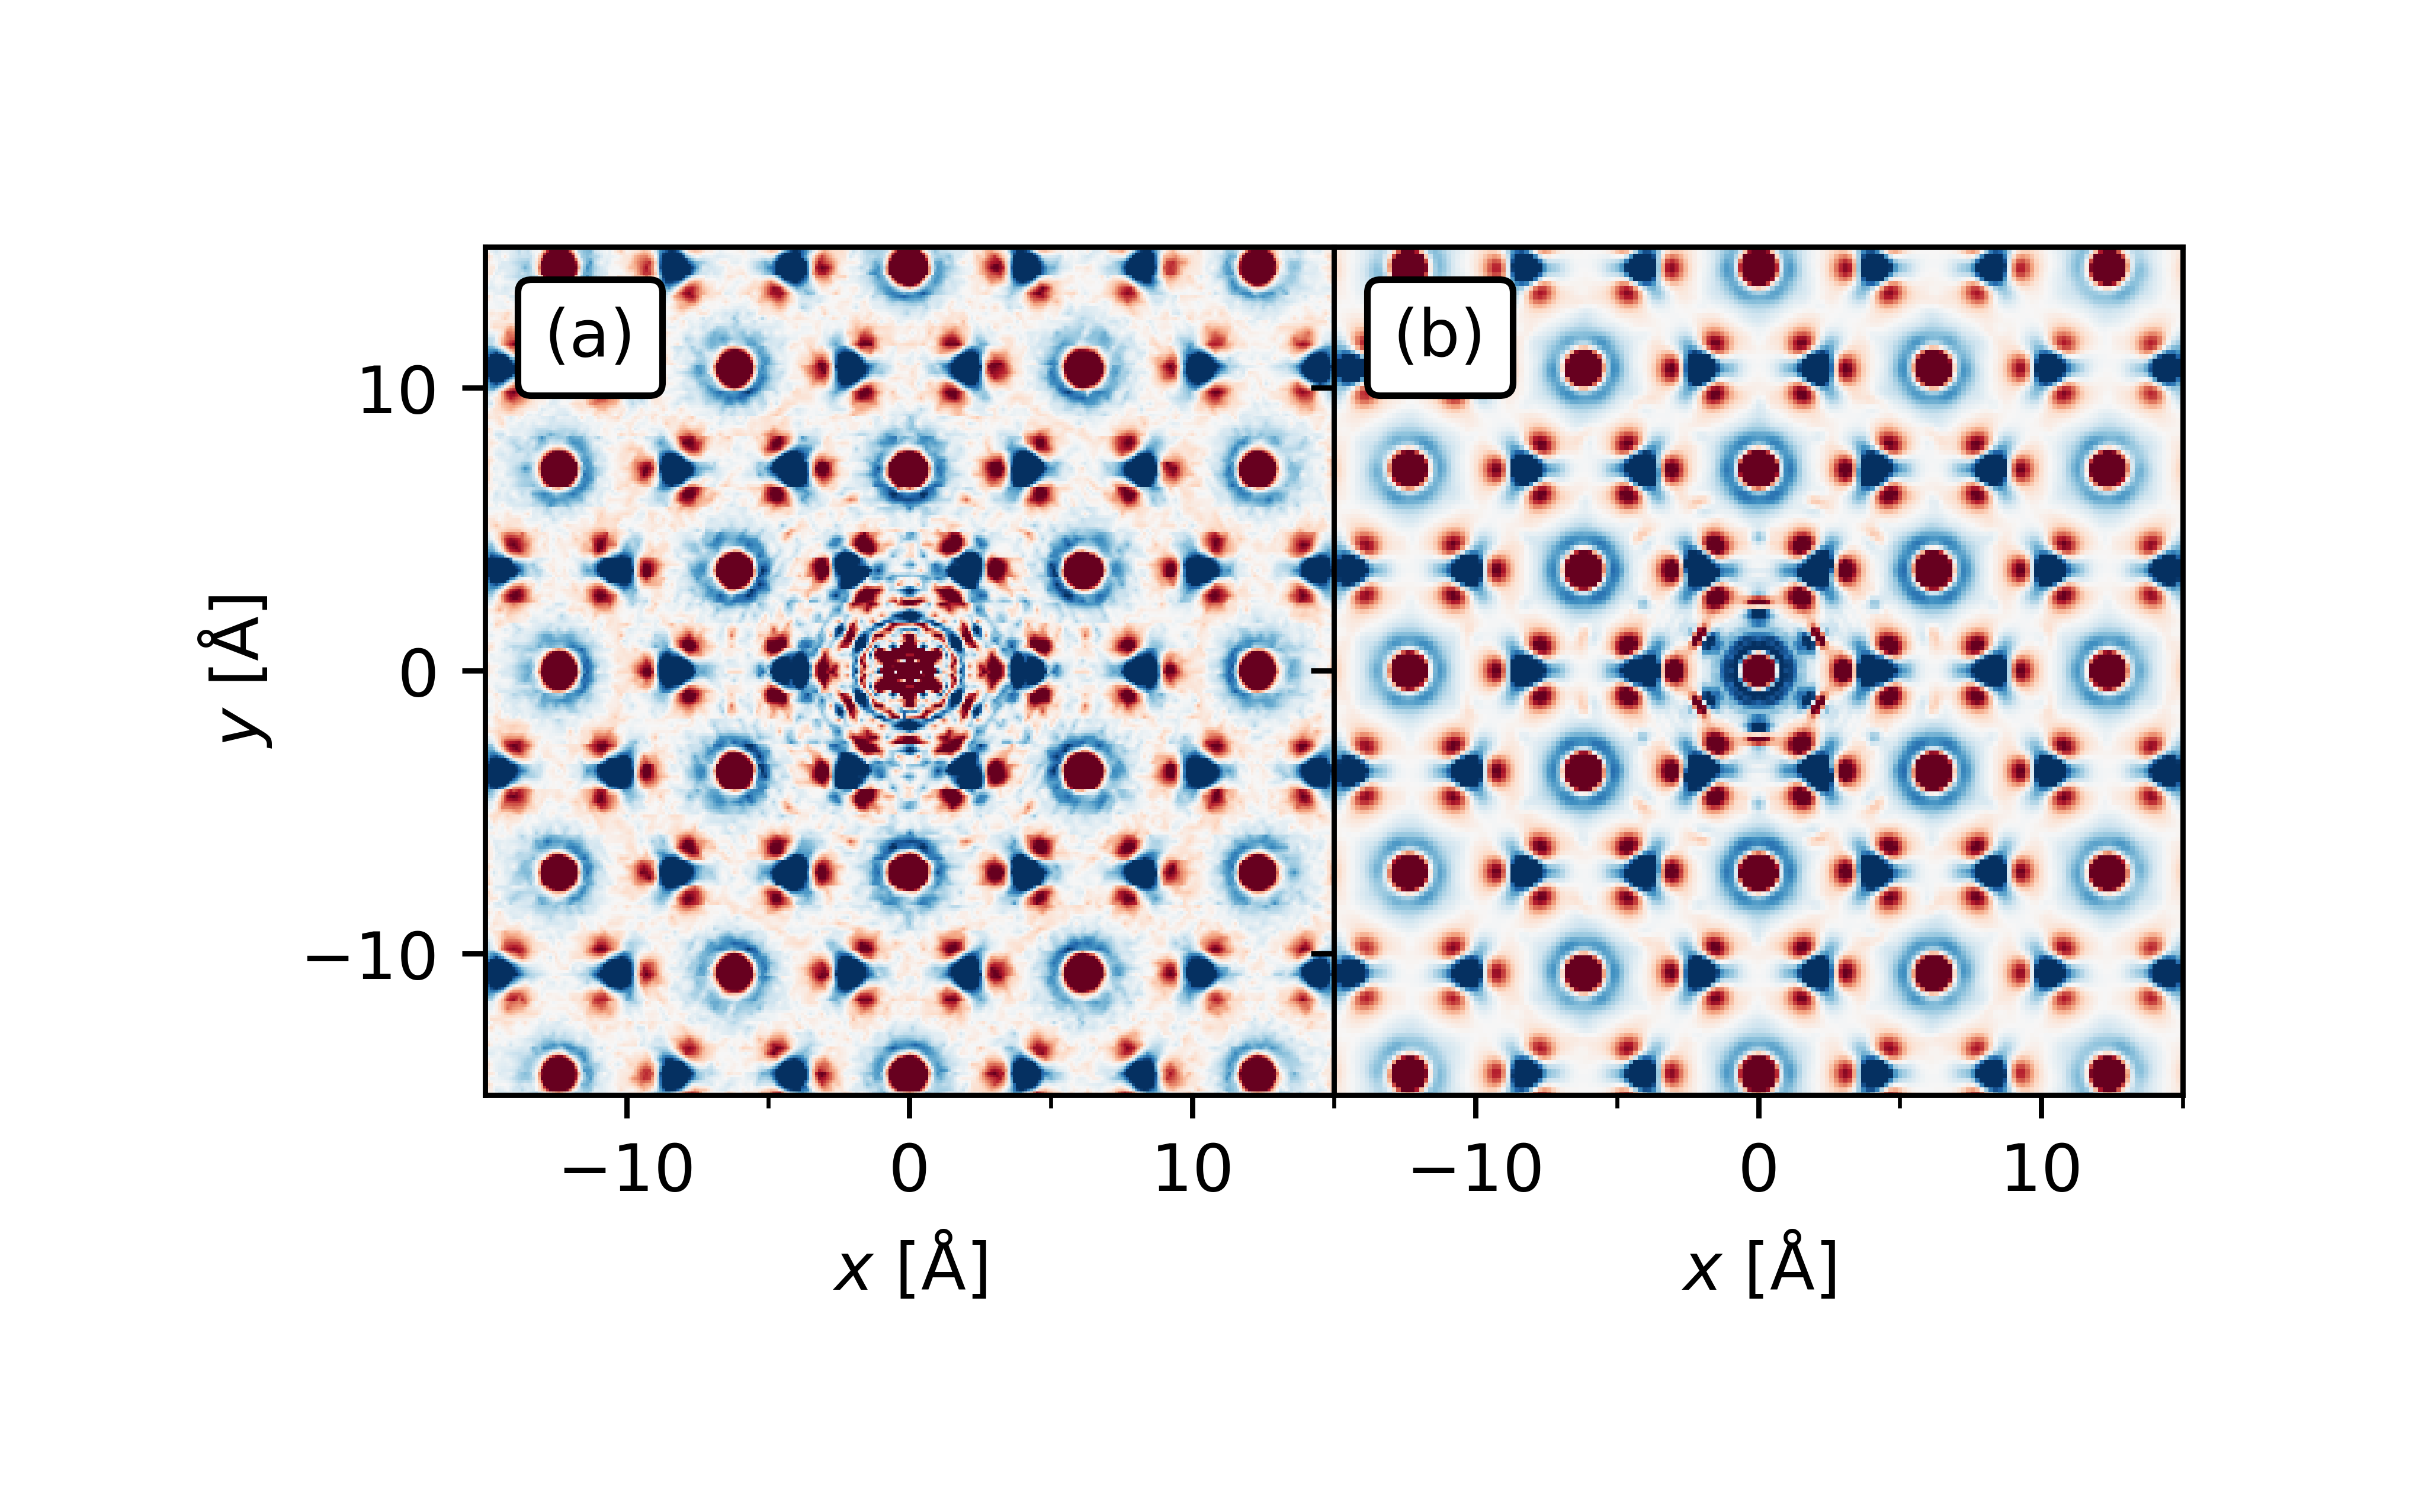

###### **Figure 1**. The 3D-ΔPDF for Cu1.95Se in the z = 0 Å plane measured on (a) in-house, and (b) synchrotron sources.

This work shows that while in-house sources have lower resolution and lower signal-to-noise ratio compared to synchrotron sources, it is possible to analyse diffuse scattering data and reach the same conclusions. This greatly enhances the availability of the method as in-house sources are more accessible and is a great step towards the 3D-ΔPDF being a more common tool for analysis of disorder.

#### [1] Weber, T. & Simonov, A. (2012). *Zeitschrift für Kristallographie*, **227**, pp. 238-247.

#### [2] Roth, N., & Iversen, B. B. (2019). *Acta Cryst.*, **A75**, pp. 465-473.

#### [3] Ehrling, S., Reynolds, E. M., Bon. V., Senkovska. I., Gorelik. T. E., Evans. J. D., Rauche. M., Mendt, M., Weiss, M. S., Pöppl, A., Brunner, E., Kaiser, U. & Goodwin. A. L. (2021). *Nature Chem.,* **13**, pp. 568-574.

#### [4] Simonov, A. & Goodwin, A. L. (2020). *Nature Rev. Chem.*, **4**, pp. 657-673.

[5] Schmidt, E. M., Neder, R. B., Martin, J. D., Minelli, A., Lemée M.-H. & Goodwin, A. L. (2023). *Acta Cryst.*, **B79**, pp. 138-147.

[6] Roth, N., Beyer, J., Fisher, K. F. F., Xia, K., Zhu, T. & Iversen, B. B. (2021). *IUCr J.*, **8**, pp. 695-702.

[7] Støckler, K. A. H., Zhang, J. & Iversen, B. B. (2024). *Chem. Eur. J.*, **30**, pp. e202402001.