3D Electron Diffraction for 2D material structure analysis

G. Anyfanti¹, D. Convertino², C. Coletti², M. Gemmi¹
¹Istituto Italiano di Tecnologia, Center for Materials Interfaces, Electron Crystallography, Pontedera, 56025, Italy
²Istituto Italiano di Tecnologia, Center for Nanotechnology Innovation, 2D Materials Engineering, Pisa, 56127, Italy

goulielmina.anyfanti@iit.it
The interest of quantum confinement effects on bidimensional materials such as graphene, MXenes, 2D transition metal dichalcogenides (TMD) and 2D silicates has expanded to multilayer systems. Their physical properties change with the number of layers, the spacing among them and the stacking sequence. For instance, 2D TMD WS₂ in its trigonal prismatic coordination monolayered phase exhibits two different stacking orders denoted as the hexagonal symmetry (2H) and the rhombohedral symmetry (3R) [1]. Characterising these parameters is crucial in determining the physical performance of these materials. Common methods have shown their success in determining the absolute thickness of 2D materials but discerning the exact number of layers as well as their stacking is still non-trivial [2]. The emerging field of the 3D Electron Diffraction (ED) in structure analysis of challenging materials [3] has triggered data collection and analysis of few-layered 2D systems resulting in a prominent method for quantitative determination of the number and the stacking of the layers [4]. By mean of 3D ED we aim to build up a methodology that direct determines the 2D materials parameters from single to multilayered structures. On this perspective we have primarily considered the case of 2D WS₂ collecting 3D ED data in continuous rotation mode. The elongated reflections in the reciprocal space due to the crystal’s size decrease were used to plot the observed integrated intensity peak distribution along the relative reflection rows, the latter known as relrods [2]. The experimental data, therefore, were compared with the corresponding calculated intensities distribution (figure 1). The difference between observed and simulated intensity reflection profile led us to first apply least square kinematical refinement exploring if this diversity would persist by refining scale factors, atomic coordinates, and thermal parameters.
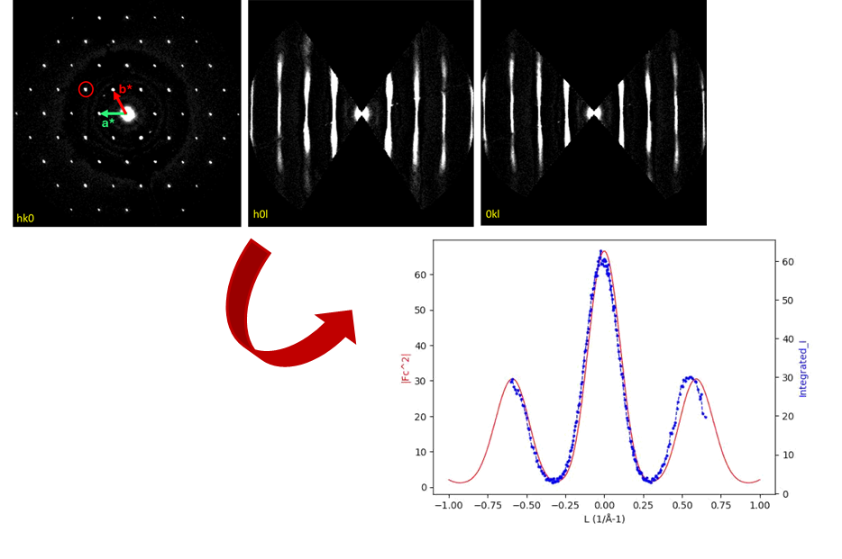

Figure 1. (Top) Section images of the reflections of a single layer WS₂ with the red circle indicating the reflection 11l; (Bottom) Experimental peak profile (blue dotted line) and simulated peak profile (red continuous line) of the 11l reflection.

[1] Toh, R. J., Sofer, Z., Luxa, J., Sedmidubský, D. & Pumera, M. (2017). Chem. Commun. 53, 3054–3057.

[2] Köster, J., Storm, A., Gorelik, T. E., Mohn, M. J., Port, F., Gonçalves, M. R. & Kaiser, U. (2022). Micron 160, 1-13

[3] Gemmi, M., Mugnaioli, E., Gorelik, T. E., Kolb, U., Palatinus, L., Boullay, P., Hovmöller, S. & Abrahams, J. P. (2019). ACS Cent. Sci. 5, 1315–1329.

[4] Gorelik, T. E., Nergis, B., Schöner, T., Köster, J. & Kaiser, U. (2021). Micron 146,.1-11.

