# Time-resolved structural amorphisation of LaMO3 perovskites by acid leaching

## E. Solé Chaos1, G. B. Strapasson1,2,3, A. Sanz Arjona1, K. M. Ø. Jensen1

### 1Department of Chemistry and Nano-Science Centre, University of Copenhagen, Copenhagen, Denmark, 2Institute of Chemistry, University of Campinas, Campinas, Brazil, 3Brazilian Synchrotron Light Laboratory, CNPEM, Campinas, Brazil

### esc@chem.ku.dk

Perovskites have been in the spotlight for the last decade due to the potential as energy materials [1]. Even though their scalability has been limited by their rather poor stability, specially under acidic conditions, we can further induce the perovskites collapse to form amorphous materials. Specifically, amorphous first row transition metal oxides have recently stood out as promising materials for multiple applications, for which the enhanced properties are often related to their short-range structural features, describing a direct synthesis-structure-properties dependence. However, synthesising these materials is challenging, [2] and thus the amorphisation synthesis is proposed as an easy and approachable one-step process, which takes place at room temperature, and it is supported only by sonication [3, 4]. Here, when acidifying an aqueous suspension of perovskite type LaMO3, the bigger cation (La) has been described to leach out, causing the structure to collapse into an amorphous MOx.

Additionally, detailed structural analysis of the amorphisation process by standard X-rays measurements is deficient, and often samples are simply described to be amorphous if no defined Bragg peaks are observed. Thus, if we aim to map structure-synthesis relations, it is required to apply more advanced structural characterisation techniques, being total scattering and pair distribution function (PDF) analysis of great interest, due to their possibilities when describing short-range structural features.

With our study, we are tracking the structural collapse of LaMO3 transition metal (i.e. Fe, Co, Ni) perovskites into nanostructured amorphous oxides, by evaluating different acidifying agents (e.g. FeCl3, HCl, HNO3) and various transition metal compositions of the initial perovskite (e.g. LaNiO3, La(NiFe)O3, La(NiFeCo)O3). Collapse of the perovskites can be observed through time-resolved X-ray total scattering measurements and subsequent PDF analysis (Fig. 1). The loss of long-range features related to the crystalline perovskite, together with observable changes in the first interatomic distances (< 5 Å), allow us to follow the leaching of the La ions and the structural rearrangements taking place in the remaining structure. These reactions will provide valuable insight into alternative ways of formation of amorphous oxides, and to the relationship between the oxide structural stability against their composition and acidic conditions, from an atomic perspective.

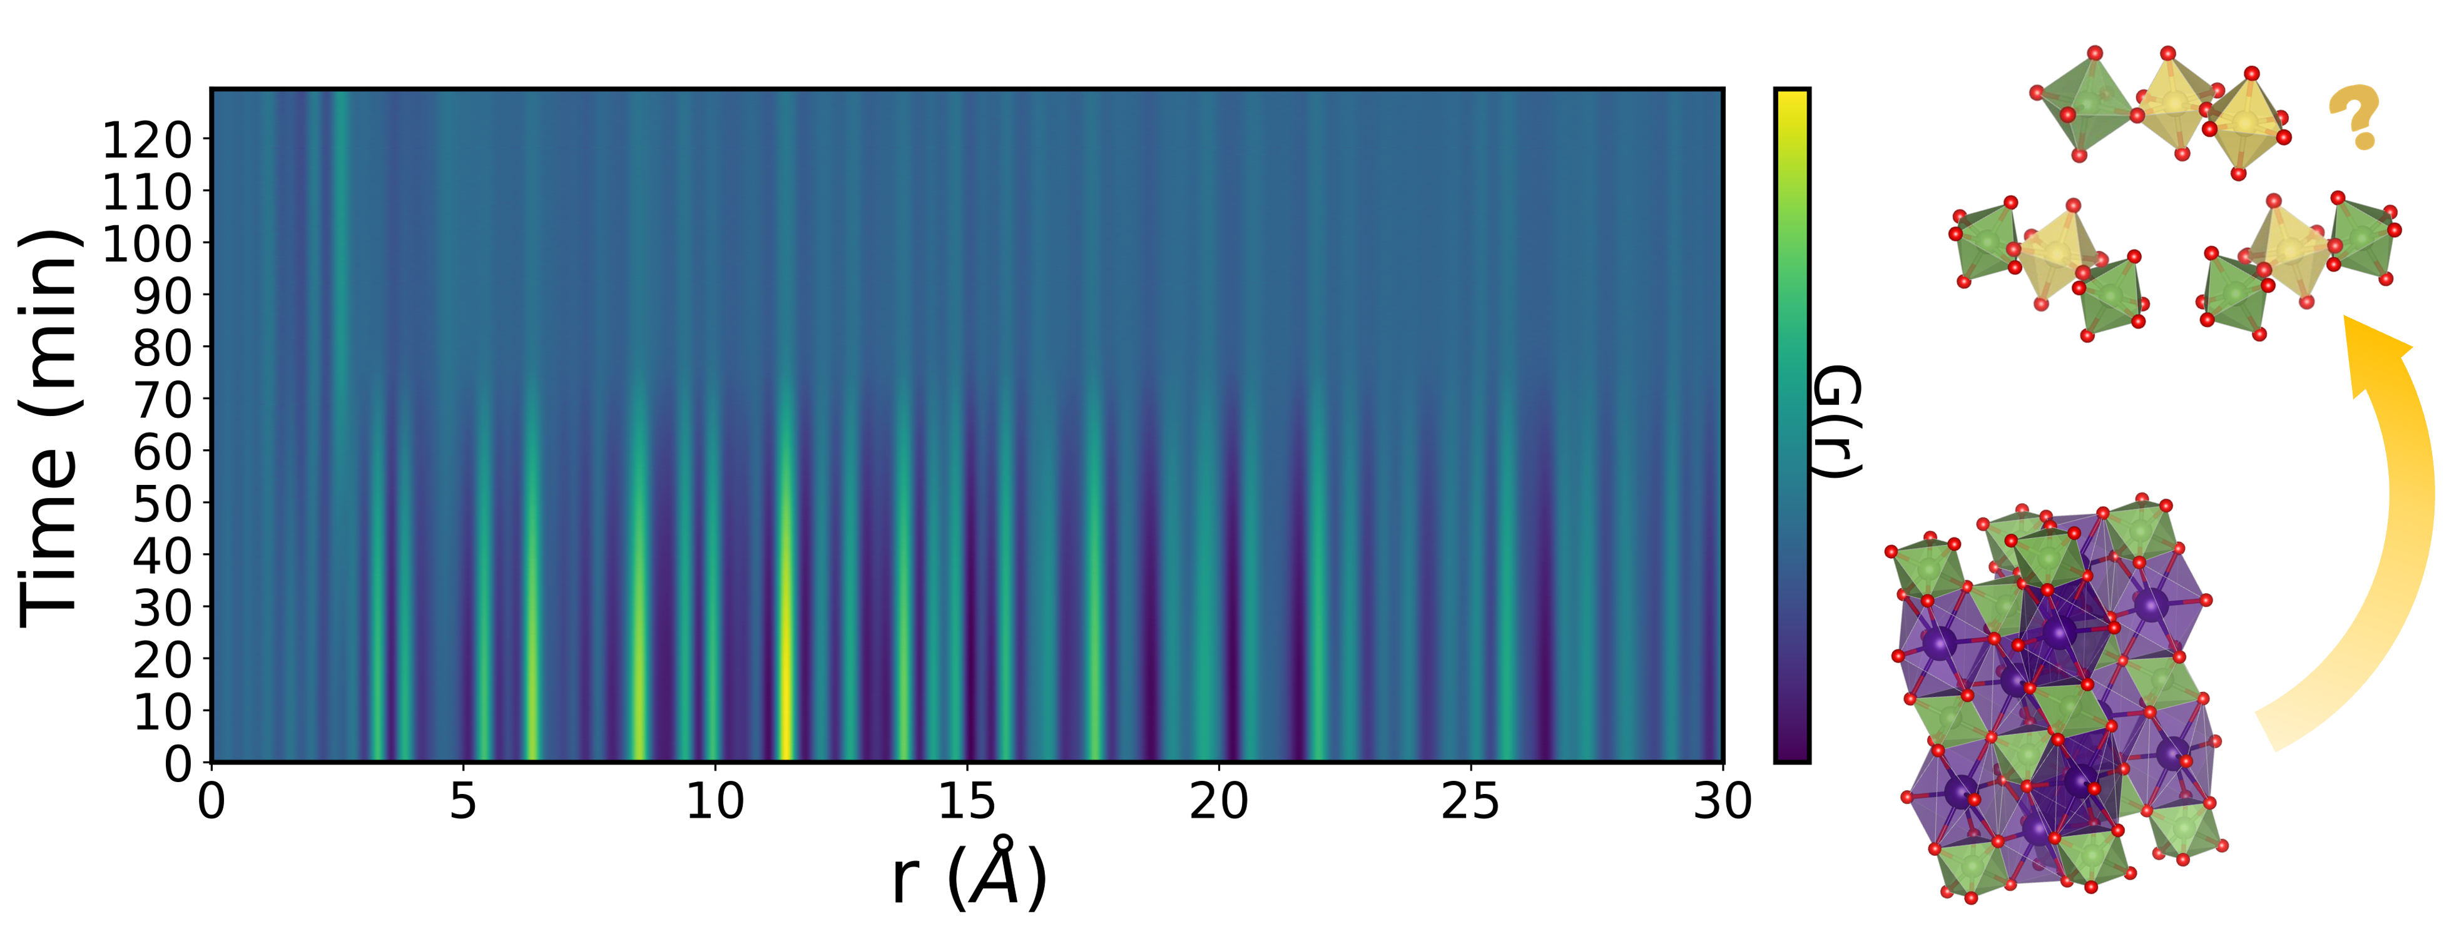

###### **Figure 1.** Time-resolved Pair Distribution Function (PDF) following the breakdown of the initial perovskite. Insets show the evolution from LaMO3 crystal structure into amorphous transition metal oxides.

#### [1] Monama, G. R., Ramohlola, K. E., Iwuoha, E. I., Modibane, K. D. (2022). *Results in Chemistry*, **4**, 100321.

#### [2] Guo, T., Li, L., Wang, Z. (2022). *Adv. Energy Mater*., **12**, 2200827.

#### [3] Chen, G., Zhu, Y., Chen, H.M., *et al*. (2019). *Adv. Mater*., **31**, 1900883.

#### [4] Geiger, S., Kasian, O., Ledendecker, M., *et al*. (2018). *Nat. Catal*., **1**, 508.